TSUMEB CORPORATION LIMITED

Request to Obtain Authorization for Expenditure

SLAG FUMING PROJECT

TCL is considering the building of a Slag Fuming Plant for the recovery �f germanium, zinc and by-product metals from slags stockpiled at the Tsumeb Smelter. The project appears technically feasible and economically attractive. Based on conservative

. estimates the 41-million Rand project has a payback of 1.3 years and an Internal Rate of Return of 46%.

Slag Fuming would enable TCL to diversify and become a major producer of the ‘high-tech’ metals germanium and gallium, for which the

demand is projected to increase substantially in the near future; also, Tsumeb's potential of zinc would again be tapped. Moreover, the project has to be seen in context with ‘the future viability of the Tsumeb Smelter.

Before a detailed project study can be submitted, a certain amount· of contracted-out research and development work is required. The

�appropriation of funds to the amount of

•) 275 000 SAR

is requested at this stage, for test work to be conducted during 1987. Because of the mentioned impact the project will have on the whole smelter, it is deemed essential to adhere to a tight timing schedule, in particular to start the test work without delay.

The attached paper outlines the technical and economic framework of the project and details of the scope of the planned R&D investigations.

SLAG FUMING PROJECT

Tsumeb Corporation Limited is considering the installation of a major plant at its Tsumeb Smelter that would allow the recovery

of metal values from accumulated slags by means of a fuming process, followed by refining to germanium dioxide, electrolytic zinc, and other saleable products. This expose outlines the project.

Summary

2-million t of lead blast furnace slag have accumulated on dump, assaying nearly 10% zinc, 2% lead, over 300 g/t germanium and 125 g/t gallium. The intrinsic metal value is estimated at 1000-million SAR.

The envisaged plant would treat the slag at a rate of 100000 t/a (300 t/d). This relatively modest treatment rate is proposed so as to cause the minimum disruption in the Germanium/gallium market.

The following high-grade, directly saleable end-products are obtained:

8600 t/a electrolytic zinc 1900 t/a refined lead_:

8 t/a 98%-Germanium dioxide, containing 26 t/a germanium 5 t/a electrolytic gallium

In addition, some copper, silver and arsenic would be recovered as by-products; the spent slag would be suitable as a cement substitute for" underground backfill.

' The process entails the following four steps:

(1) Slag fuming, a pyrometallurgical process resulting in an oxidic fume enriched in zinc, ‘lead, germanium and gallium, suitable'

for further processing, in a silver-containing copper matte,

and arsenic trioxide.

(2) Fume treatment, a hydrometallurgical process resulting in a zinc sulphate liquor, a lead sulphate sludge, and a mixed germanium/gallium oxide. The sludge would be treated in the lead smelter to produce refined lead.

(3) Purification of the zinc liquor, followed by electrolysis, to obtain zinc cathodes for sale.

(4) Germanium and gallium recovery, resulting in a high-grade Germanium dioxide, obtained by hydrolysis of the distilled tetrachloride, and in electrolytically refined gallium.

The plant could come on stream early 1991 and would operate for 20 years. Estimated capital investment is in the order of

40-million SAR. Under the assumed price/cost scenario, an annual net profit of 18-million SAR is calculated, resulting in a pay­ back period of 1.3 years and an internal rate of return for the project of 41%.

Most of the processes of technology and underlying metallurgy are well established. However, the following test work is still required:

(1) Investigation of alternative high intensity fuming processes, such as St Joe's Flame Reactor and the plasma furnace.

(2) Establishing the optimum conditions under which gallium can be fumed.

(3) Establishing the best hydrometallurgical route that should be followed when treating the fume.

Costs for this first phase of R&D test work would be 275000 SAR.

Introduction

The present economic climate suggests that TCL should not only make optimum use of its available resources, but also diversify

as regards its products. Two recent projects at the smelter exemplify this attitude: The Slag Milling Plant successfully recovers copper and silver from stockpiled reverb furnace slags and paid for itself after one year of operation; the Harris Plant has been erected and the recovery of antimony, lead and silver from stockpiled caustic slags and current arisings has commenced.

In a similar fashion, zinc and lead could be recovered from stock­ piled blast furnace slags by the well-established slag fuming process. However, such a plant would not operate profitably, were it not for the concurrent recovery of rare metals. Tsumeb is in the fortunate position to command a substantial proportion of the total world reserves of germanium (some 800 tin slags, as compared to an estimated

380 tin the United States and 4500 t worldwide) and also a high-

'Grade source of gallium. Both germanium and gallium as 'high-tech' minor metals, their main applications being in the

electronics industry (Ge- and GaAs semiconductors), in infrared optics

, and glass fiber conductors. Demand and supply of these metals show an increasing tendency (e.g., for GaAs an increase in demand of 20% p.a. over the next five years is estimated for Western Europe). If

Correctly timed, TCL could successfully enter an expanding market, as opposed to that of its classical metals copper and lead, for which stagnant demand and prices can be redacted.

Background

During the 1 601s TCL produced and sold high-grade germanium dioxide, obtained from roasting a magnetically upgraded copper concentrate and leaching the calcine, followed by distillation of GeC 4. Production ceased on account of market conditions; the germanium distillation plant was mothballed but could be reactivated. Since then, the germanium tenor in Tsumeb ore dropped substantially, and all of TCL's germanium reserves are virtually confined to stockpiled smelter slags.

In 1970 TCL submitted a feasibility study for a 500 t/d slag fuming plant. The flowsheet included the addition of 35% cold slag from dump to molten, arising blast furnace slag. In a de-leading step zinc clinker was obtained for sale, in addition to an upgraded fume that went to leaching. Germanium was precipitated by tannin, refined by distillation of its tetrachloride, and hydrolyzed to 98%-Ge02 for. Sale. Although the project was thoroughly studied and showed a

good return, it was not approved on account of (mistaken) market doubts.

Renewed interest arose in 1980, when TCL was approached by the German Preussag concern that was looking for a secure and long-term raw material basis to support its production of refined germanium.

Modern, high-intensity slag·fuming was considered, and very successful test work conducted by KHO in its CONTOP pilot plant in Cologne

(at the expense of Preussag but using TCL slag and coal). The under­ standing was that TCL should produce an enriched fume that would be purchased by Preussag for treatment at its Nordenham smelter for

the recovery of zinc, lead and a germanium concentrate, the latter to be refined at Preussag's Rare Metal Works. However, the economics of the project turned out to be unfavorable, and the,

project subsequently floundered, mainly due to the low prices offered for the metals contained in the low-grade fume sold by TCL, and due to the high transportation costs.

Present Situation

Five years later, the economics look much brighter due to the massive devaluation of the South African Rand. The project was re-evaluated under the following scenario:

(1) The recovery of metal values from slag will be financially attractive only if the process is designed to yield high-grade end-products that are suitable for direct sale to consumers.

(2) Present market conditions strongly suggest to include the recovery of gallium in any future process.

(3) Consideration should be given to modern processes, such as

high-intensity fuming using oxygen, and advanced hydrometallurgical techniques using solvent extraction/ion exchange for germanium/ gallium recovery, with a view to maximize recoveries and at the same time keep the plant size small.

A valuable asset for the project is not only the fact that TCL has at its disposal an established infrastructure, but also that it commands a substantial know-how in respect to the production of refined germanium dioxide from past experience, and in respect to the underlying technology and metallurgy from previous studies and test work.

Slag Reserves

Smelter furnace slags are granulated before being dumped, which makes them easily reclaimable. Other than in the wet season nondrying would, be required. Particle size would be suitable for dry milling, for which existing equipment could possibly be used if required.

Two types of slag are available

|  |  |  |
| --- | --- | --- |
| Slag Type | Lead Blast Furnace | Copper Reverb Furnace |
| Tonnage on Dump | 2 000000 t | 650 000 t |
| Current Arising | 80000 t/a | 60 000 t/a |
| Zinc Assay | 10 % | 4% |
| Lead Assay | 2 % | 3% |
| Germanium Assay | 300 g/t | 400 g/t |
| Gallium Assay | 125 g/t | 80 g/t |

The indicated grades of germanium reflect the average of the dumped slags; the older parts are richer (and will be worked up first), whereas the current arisings are much leaner. This is the reason why only cold slags from stockpile are considered for fuming and not,

as usual, molten arising slags. The slag reserves on dump have lately been verified by drilling (lead blast furnace slag) or while being treated (reverb slag in Slag Mill).

The project is based on the treatment of blast furnace slag only, for the following reasons:

(1) The zinc tenor is more than twice that of the reverb slag; revenue from zinc will cover most of the operating costs.

(2) The germanium tenor, though slightly lower than in reverb slag,

is sufficient to produce a fifth of the present world consumption, which is deemed enough.

,(3) The gallium tenor is substantially higher hand in reverb slag, which should ensure a higher recovery.

(4) The slag composition, being much higher in lime than reverb slag, render the spent slag-suitable to substitute for cement in underground backfill (a la 0'0kiep).

In case we wished to increase germanium production or to extend the life of the project, copper reverb slag (tailings from the Slag Milling Plant) could be admixed to the fuming charge.,

The Fuming Process

Slag fuming is an established process and practiced by several plants worldwide for the recovery of zinc and lead; only the El Paso smelter used to recover germanium as well. The process consists of blowing pulverized coal into a bath of molten slag, which causes zinc to be volatilized as the metal, lead as either the metal or the oxide, and germanium as Geo. Admission of surplus air to the gas phase oxidizes theses species to Zano, PbO, and GeO2, all of which are then collected as a fume the excess air also promotes the oxidation of CO to CO2.

The latter is the prevailing reaction in conventional slag fuming, which energy-wise is said to operate like a large and rather in­ efficient boiler. Processing is batch-wise, and in our case the slag from dump had first to be melted in a separate unit.

More recently developed processes use oxygen, either pure or in enriched air, to achieve high thermal loads in relatively small-sized reactors; KHD's CONTOP process (cyclone smelting cum top lancing) and St Joe's Flame Reactor belong to this category. Successful pilot plant tests demonstrated the suitability of both versions to recover metal values from cold slags at high yields. The principal feature of these modern processes is the attainment of extremely high temperatures,

which greatly enhance the volatilizations reactions. Dry and finely ground slag would be treated in a continuous operation.

Comparison between high intensity and conventional fuming:

1. High-intensity fuming achieves higher metal recoveries to fume, in particular as regards germanium:

Zinc 90 92 % VS 90 %

Lead 97 - 99 % vs 96 %

Germanium 80 - 90 % vs 70 %

(2) For all we know, capital costs for both the KHO and the St Joe high-intensity plants are comparable to those of a conventional plant. Because the KHO is a two-step process, its operating costs are substantially higher than those of the other two processes, for which they are comparable.

(3) High-intensity fuming plants could be build much smaller than conventional ones, which is particularly true for the reactor itself and the fiue gas train including the waste heat recovery system. The need for a substantial oxygen plant is offset by the required separate smelting unit to achieve conventional fuming of cold slag only.

While conventional fuming will still be considered in any assessment, the main emphasis will be directed towards modern, high-intensity technology; particularly St Joe's Flame Reactor appears attractive.

Its alleged performance has, of course, to be verified by site visits of TCL staff and by the envisaged test work. The Flame Reactor was, however, taken as a basis for the present initial economical assessment of the project.

•The required u e of tonnage oxygen in high-intensity fuming processes is not regarded as a disadvantage: numerous uses of oxygen in other

applications have been identified (not least in copper smelting).and

are considered essential in the long run to keep the Tsumeb Smelter

competitive.

Rather recently the Plasma Furnace entered the field of potential fuming processes. Whether indeed it is suitable has first to be established; however if so, it would be a very attractive alternative to all other processes because of its much lower capital and operating costs. On account of their experience with plasma technology the Council for Mineral Technology (MINTEK} is regarded as the most suitable place to have some skirmishing test work done.

Gallium

Not much has been published about the pyrometallurgical extraction of gallium, and in particular about its behavior under slag fuming conditions. At the Italian Porto Marghera Zinc Plant gallium is recovered from zinc leach residues by fuming in a rotary furnace at 1250 °Ct at which temperature the charge is molten. A more recent Chinese publication describes a similar process treating a leach residue by the Walz process. It will appear as if the element could be volatilized via its suboxide Ga20 at specific temperatures and redox potentials. The planned test work at St Joe's pilot facility would also serve to establish these conditions.

Once recovered to fumet gallium would be concentrated together with germanium by solvent extraction as described in the literature.

The subsequent electrowinning of gallium metal0from alkaline

,solution is standard practice in the aluminum industry.

One expects to obtain some 15% by mass of the slag as fume (45 t/d), containing about 60-65% zinc, 10-15% lead, and 0.2% germanium. If one leached this fume with sulphuric acid (regenerated in the zinc tank house), lead would remain as a PbS04 sludge, while zinc and germanium would be solubilized. From this solution germanium could be recovered by the old-fashioned precipitation with tan in or chestnut extract, or preferably by solvent extraction.

The two main purposes of this process are:

(1) To achieve a quantitative separation between zinc and germanium (including gallium); we envisage hydrometallurgical methods.

(2) To remove all elements that are deleterious to zinc electro­ winning from the zinc-bearing liquor. Except for germanium, these elements would include arsenic, halogens, silica, and possibly molybdenum; both pyro- and hydrometallurgical methods are envisaged.

It is clear that the process could be quite complex, depending on the level of impurities in the fume. The required test work would first be conducted on a laboratory scale and subsequently on a

pilot plant scale. Also in this case MINTEK is regarded the best address to go to.

The final two steps of zinc electrowinning and germanium refining are well established and ought to pose no problem, given good separation and purification of the two process streams.

Summary of R&D Work

In order to make the project a success, the following test work is deemed necessary and essential:

(1) Pyrometallurgical tests to establish the most suitable fuming process, which would allow a ranking according to process in the feasibility study. The metallurgy of the conventional and the KHD CONTOP fuming processes is regarded as known, except for the behavior of gallium. Updated and more precise capital and operating cost data have, however, still to be obtained. The metallurgical performance and the costs of t e foll wing two alternative fuming processes have yet to be evaluated:

(a) St Joe Flame Reactor

50 t of Tsumeb lead blast furnace slag would be shipped to St Joe's demonstration/pilot plant·in the States, located

at Monaca, Pa. Either South African coal (which in this case

would also have to be shipped by TCL) or a similar American coal would be used for the fuming test, which would consist of three separate runs, take approximately. Three weeks and could be performed in August 1987 at the earliest. The resulting fume, 7 t altogether, would be returned and be available for the hydrometallurgical/ leaching investigations (lab and pilot plant). Costs for this test work will be 108 000 SAR.

(b) Plasma Furnace

A maximum of 1 t of Tsumeb’s Slag would be required by MINTEK to conduct some skirmishing fuming tests in either their

50 or 100 kW furnace. The tests could already be started.in April 1987. Costs are estimated at 20000 SAR, would however be lower if the process proves absolutely unsuitable. If successful, the recovered fume could be made available (to

the lab next door) for hydrometallurgical test work at a rather early stage.

(2) Hydrometallurgical tests to establish the best way of impurity removal and of germanium/gallium extraction from fume. The investigations would be carried out by MINTEK. An essential requirement is, of course, the availability of fume.

(a) Laboratory-Scale Test work

Costs 108000 SAR; the indicated duration of one year is believed to be excessive and ought to be shortened to, say, six months. This work should commence as soon as can

be arranged, and would initially be on artificial fume )until such time-when-the real one becomes available.

(b1 Pilot Plant Test work

Based on the lab-scale results, the effect of accumulating impurities on zinc electrolysis would be studied and the measure of product quality be assessed that can be achieved under plant operating conditions. Costs of

1.2-million SAR were quoted, and a substantial tonnage of fume (e.g. ex St Joe test) would have to be made available. However, before this test work is entered into in 1988, the situation of the whole project would be re-assessed and renewed approval by the board be sought for this substantial expenditure.

)

Recent negotiations between GFSA and MINTEK resulted in a reclassification of the lab-scale work from a C- into a B­ category project (the sponsor to pay only half of the costs). For the time being, the pilot plant work still qualifies as a C-category project (fully sponsored, confidential contract work); this, however, may be subject to further negotiations.

**Consultancy**

Mr. George L. Shadford of Toronto would be available as a metallurgical consultant. In this capacity he assisted in the development of the Apex/Utah project of Musto Exploration Ltd, which was com­ missioned in late 1985. Incidentally, Mr. Shadford was an employee of TCL in the 19601s, when he was involved in the design of the Tsumeb Germanium Plant of that time.

Costs incurred for consulting services and travelling expenses for TCL staff during 1987 were estimated at 39 500 SAR.

**Conclusions**

(1) The Slag Fuming Project appears to be economically attractive.

(2) It would fit perfectly into the future development of the Tsumeb Smelter.

(3) The slag reserves are real and readily available.

(4) TCL feels confident that it could handle a project of this magnitude and prides itself of substantial know-how in-this field.

(5) Funds that amount to less than 1% of the total envisaged capital investment are requested at this stage to have the necessary R&D work performed.

**ANNEXURES**

1. Summary of most important Project Data

2: Project Time Schedule

3. Accumulation and Value of Stockpiled Slag

4. Schematic Process Flowsheet

5. Metal Prices and Product Revenue

6. Estimated Capital Investment

7. Estimated Operating Costs

8. Financial Analysis/ Discounted Cash Flow

9. Sensitivity Analysis

10. Capital Cost Comparison for various Fuming Processes

11. Operating Cost Comparison for various Fuming Processes

12. The St Joe Flame Reactor/ Letter by L Harris 19,8,86

13. Test work at St Joe/ Telex by L Harris 30.1.87

14. Lab-Scale Hydrometallurgical Test work / MINTEK 25.8.86

15. Pilot Plant Test work / MINTEK 4.9.86

16. Effects a Fuming Plant would have on the Tsumeb Smelter

ANNEXURE 1

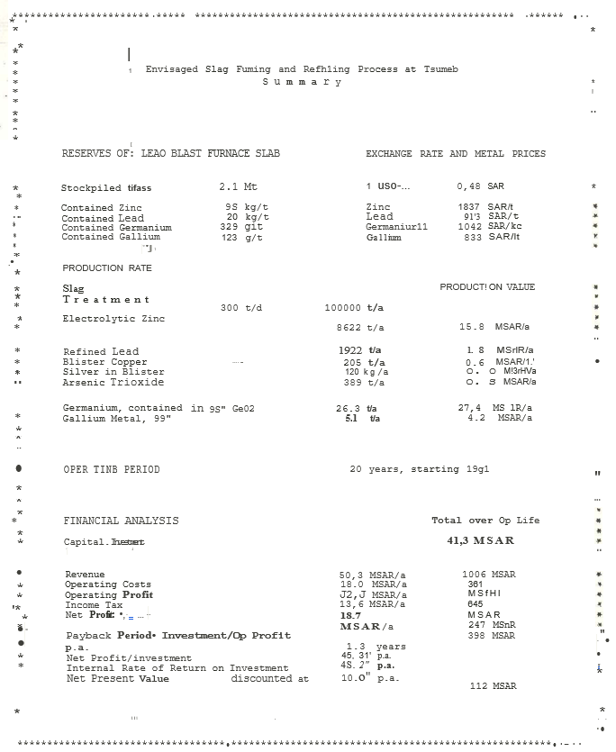

ANNEXURE 2

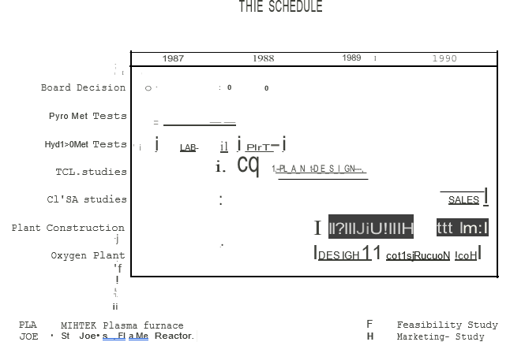

ANNEXURE 3

ANNEXURE 4

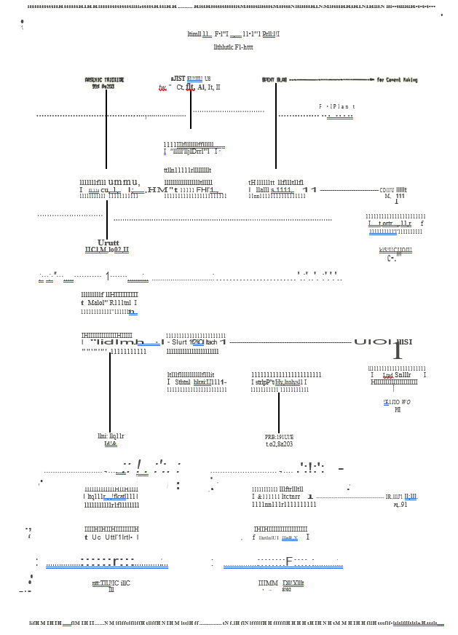

ANNEXURE 5

ANNEXURE 6

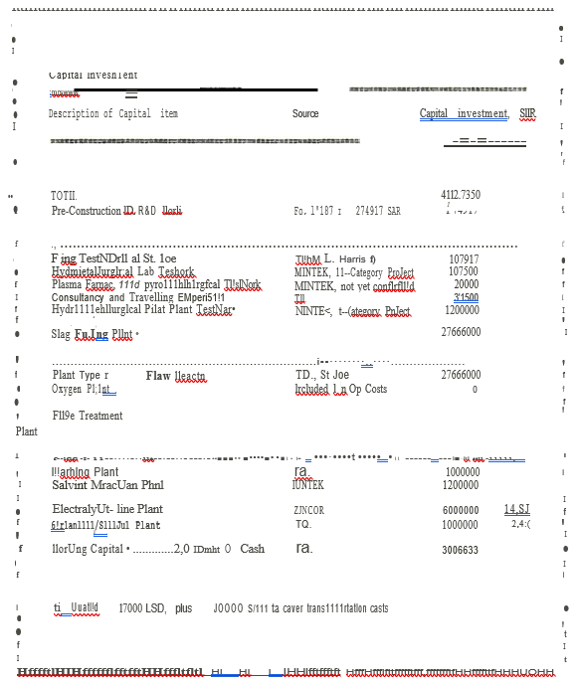

ANNEXURE 7

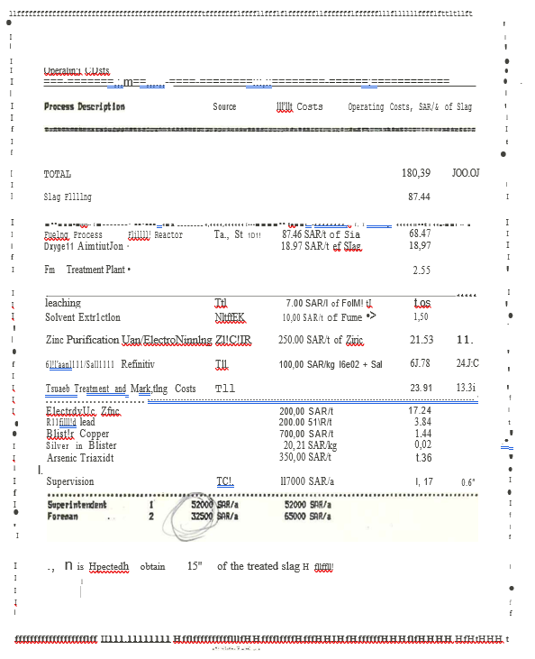

ANNEXURE 8

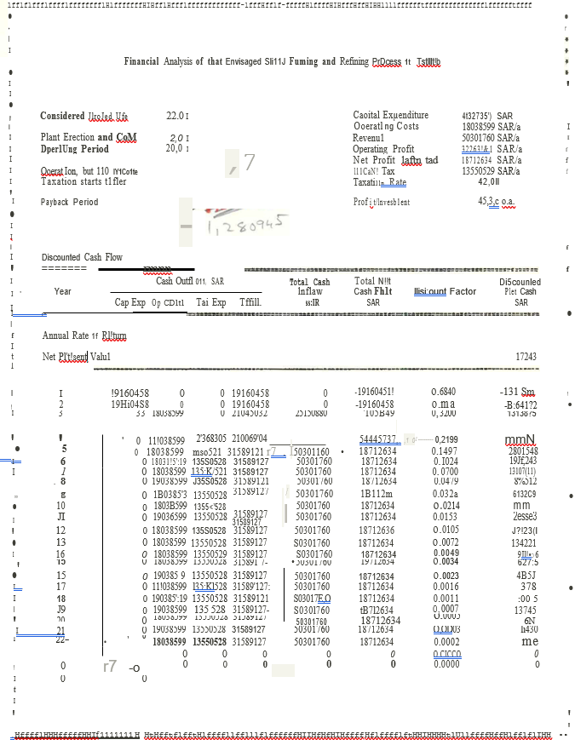

ANNEXURE 9

ANNEXURE 10

ANNEXURE 11

ANNEXURE 12

NEWMONT MINING CORPORATION

200 PARK AVENUE

NEW YORK ,N Y, 10166

LEONARD HARRIS

VICE PRESIDENT

METALLURGICALL OPERATIONS

August 19, 1986

Letter 18450

Mr. H. A. R. Meiring General Manager and Chief Executive Officer

Tsumeb Corporation Limited

P.O. Box 40

Tsumeb

South West Africa/Namibia Dear Bob:

Subject: St. Joe's Flame Reactor

As noted in my telex to you of June 24, 1986 on the above subject, herewith some further information concerning the possible use bf St. Joe's flame reactor for fuming TCL's lead blast furnace slag as obtained_ from the visit by John Yannopoulos and me to the St. Joe demonstration plant i Monaca on June 24, 1986.

Between 1971 and 1974, St. Joe studied various possibilities for fuming zinc from flotation concentrates. The aim was to develop a low-energy process agreement was signed with Lurgi Corporation of Germany in 1974 and testing undertaken jointly between 1974 and 1978 with the Lurgi cyclone process which ultimately resulted in the flame cyclone installation at ND.

Disagreements between the two companies on technical

·Matters culminated in a dissolution of the partnership in 1978 and the formation of another partnership with Sverdrup Technology, Inc. and the construction of a mini plant in Tullahoma, Tennessee. This plant operated intermittently between 1981 and 1983 and was rated at 5,000-8,000 tpy.

In 1983, a 15,000-20,000 tpy $1.7 million demonstration unit was built at Monaca, Pennsylvania which has operated intermittently since that time for the fuming of zinc, from zinc calcine, lead blast furnace slag (Herculaneum), zinc residues, zinc secondaries, cobalt/nickel residues and electric arc furnace (EAF) dusts. · Its h s also been

operated as a coal gasifier aimed at producing low-BTU gas

The plant is presently operating under. Two contracts. One by the Centerfor Metal Production (CMP) which is an association. of 20 steel companies, for testing with EAF dusts, and one by the U.S. Bureau of Mines lUSBM) aimed at fuming zinc. From other materials.

It is of interest to note that the fuming of zinc from EAF dusts (15%-20\ Zn) has doubtful economics and that the justification is merely environmental, i.e. these dusts are considered hazardous by the us EPA authorities and must be "sanitized” “before disposal or return to

the steel-making process as noted in Dr. Abramowitz's letter to me of June lj, 1986 (copy attached).,

A complete description of the process and its application to the treatment of EAF dusts are shown in the attached brochure, "The St. Joe Flame Reactor EAF Dust Treatment Process."

This reactor is not unlike the ND and KHD reactors except that a mixture of air and oxygen is fed to it instead of pure oxygen as for the ND reactor and it is a cylinder rather than a cyclone in the case of the KHD reactor.

The demonstration plant is designed for 8-hour test runs. Sixteen-hour test runs are the maximum periods operated to date. It is obvious that before it can be accepted

by industry, continuous operation of several weeks, or even months, is required.

Some 200 tons of Herculaneum lead blast furnace slag assaying 11% zinc and 2\ lead was treated in this reactor in 1983. The results of these tests are shown in the attached sheet, "Herculaneum Slag Test Program," and

J) some further data and estimated performance parameters for a 200,000 tpy plant are shown in the attached sheet, "St. Joe Minerals Corporation Flame Reactor Process

Treatment of Lead Blast Furnace Slag."

Although it is touted as a "low energy" process, the

use of 3.9 tph of coal and 5,250 SCFM of oxygen-enriched air (56.4% o2) for 25 tph of slag; does not seem to substantiate this claim.

What is impressive are the high fuming efficiencies reported at 92% for zinc and 96% for lead and the high carbon utilization efficiency of 90%. According to Dr. Abramowitz and Mr. Arthur Stanze of St. Joe, carbon efficiencies have been improved to 95-97%.

Also, impressive (if true), is the claimed preliminary

• capital cost estimate for a 20,000 tpy slag fuming plant of $1.5-$2.0 million, excluding a slog grinding plant at a Midwest U.S.A. location. ·

You will note that the nerculaneum slag fuming tests were conducted with slag ground to 70% minus 200 m sh. According to the st. Joe personnel, tests with coarser slag gave lower extractions but a plant "could possibly be designed with different. Geometry to give better results."

Both ground coal and coke can be used as a reductant

in the reactor and the demonstration plant is available for test work following the present heavily booked period. A 20–30-ton sample would be required, together with a sample of coal for a one-week test at a cost of

$25,000-$30,000.

The claimed low capital cost of a plant using St. Joe's technology appears to be an attractive feature of this process, which is offset by the fact that it remains unproven on a commercial scale at this time and that it requires a tonnage oxygen plant.

The St. Joe staff will make a more detailed estimate of a plant employing this technology for TCL if we supply

them with the annual tonnage desired for treatment and the assays of the slag to be fumed and the coal to be used

as reductant.

If your preliminary calculations show an economic justification for the treatment of Tcr lead blast furnace slag for zinc, lead and germanium recoveries by this process, I suggest we avail ourselves to St. Joe's offer.

I would expect that their capital cost estimate would be biased on the low side which could be checked by

TCL's Engineering Department and others if deemed worth­ while.

Best regards.

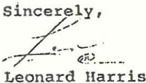

LH:mh cc: GRParker

DCRidinger

- RC

JCYannopoulos

ANNEXURE 13

